**TINKERCAD-BLOQUE**

Tinkercad:-

Tinkercad is a free-of-charge, online 3D modeling program that runs in a web browser. Since it became available in 2011 it has become a popular platform for creating models for 3D printing as well as an entry-level introduction to constructive solid geometry in schools. Tinkercad.

Bloque:-

Tinkercad Codeblocks utilizes the same familiar Shapes found in Tinkercad’s 3D workspace and allows users to modify those Shapes with block-based code that’s easy to read and remix for users of all skill levels

**Arduino Board checking:-**

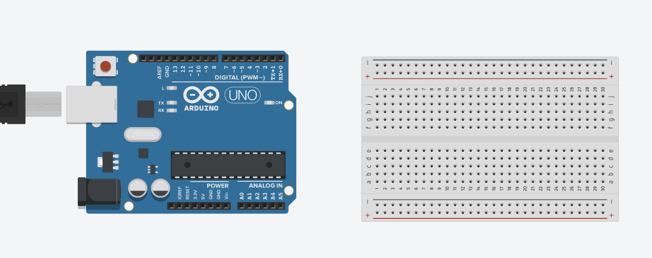

**Code:-**

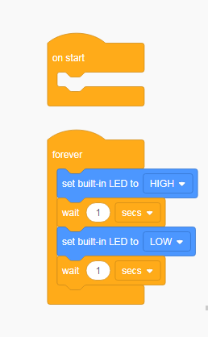

**Arduino board Connection checking:-**

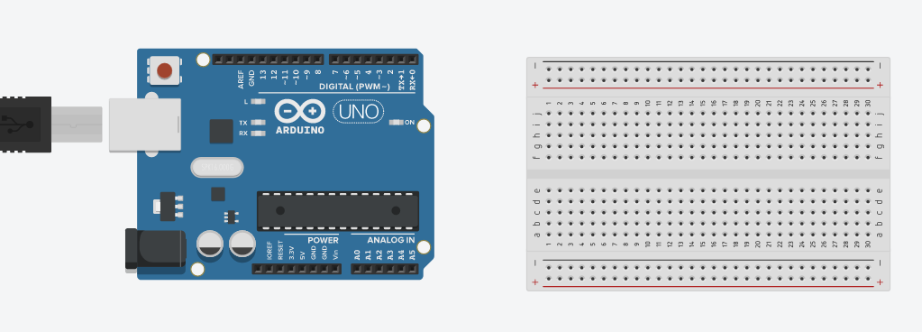

**Code:-**

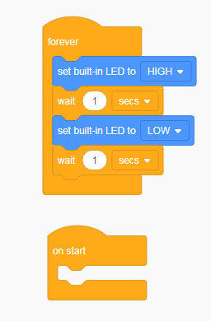

**Board light blinking Ready to connection:-**

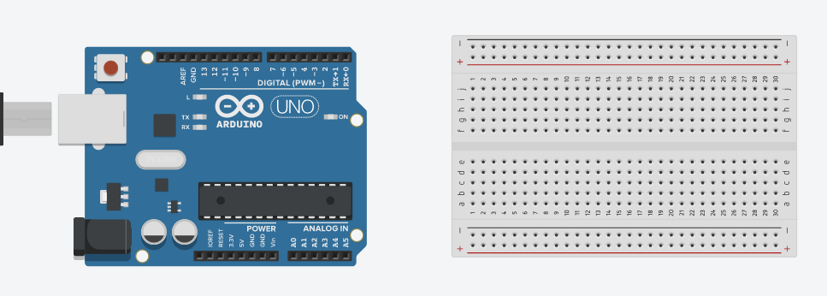

**Code:-**

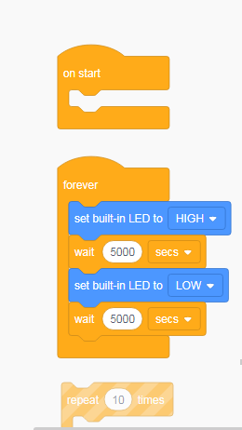

**LED light blinking:-**

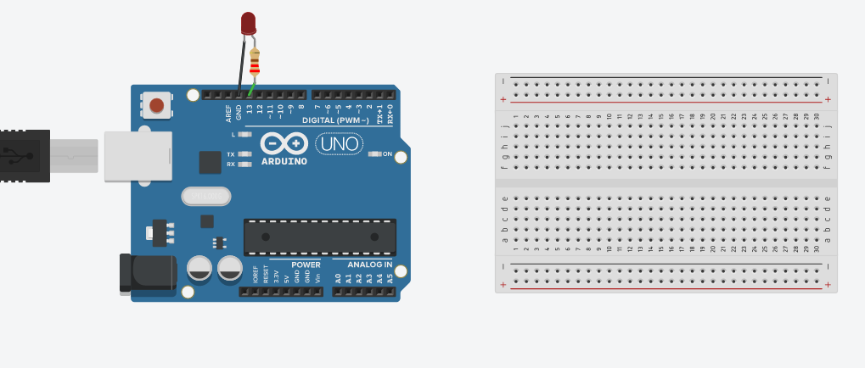

**Code:-**

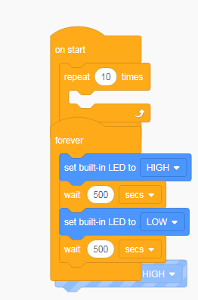

**Led light blinking some time interval:-**

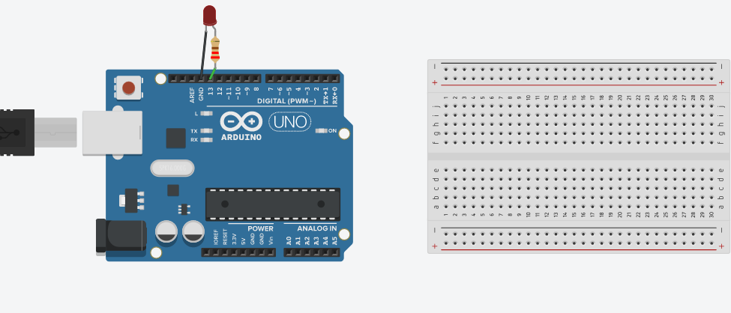

**Code:-**

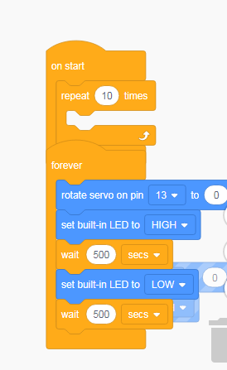

**Digital Write operation cheking Led light:-**

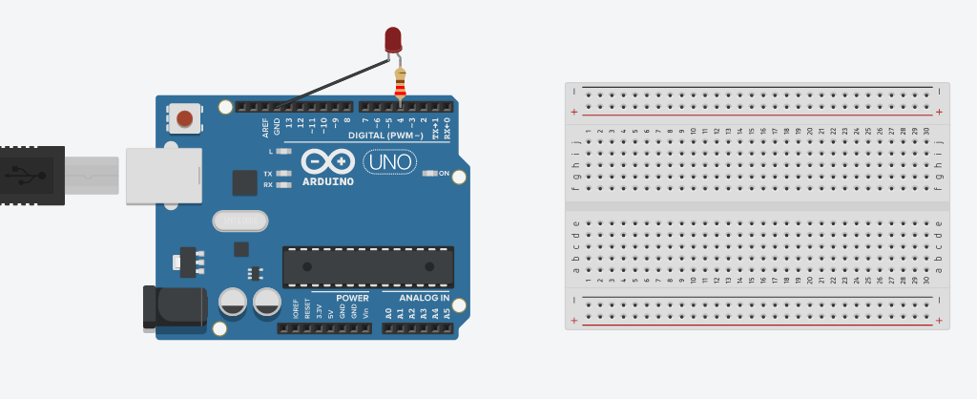

**Code:-**

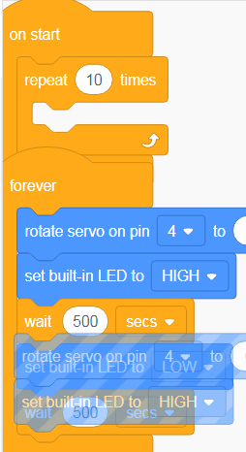

**Code:-**

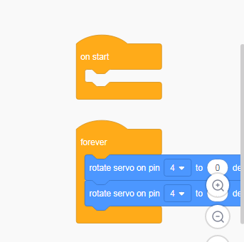

**Code:-**

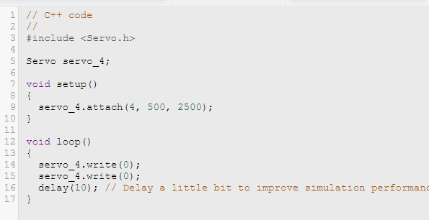

**Pushbutton using to checking board:-**

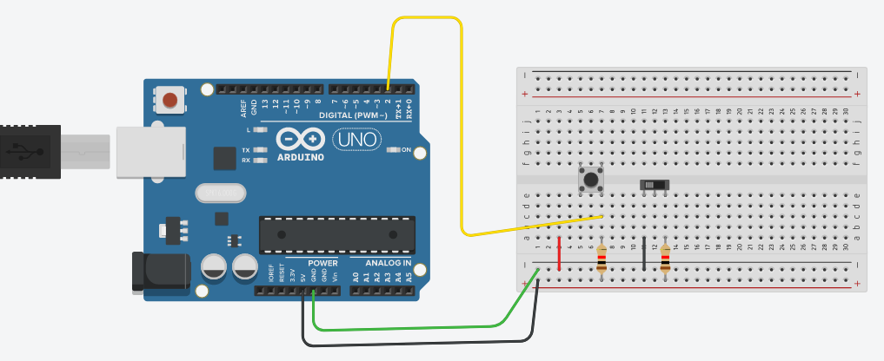

**Code:-**

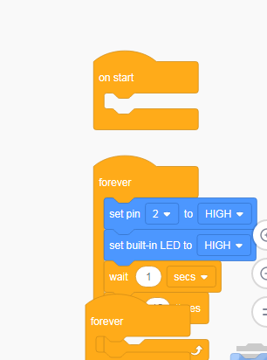

**Potentiometer using to check the analog write:-**

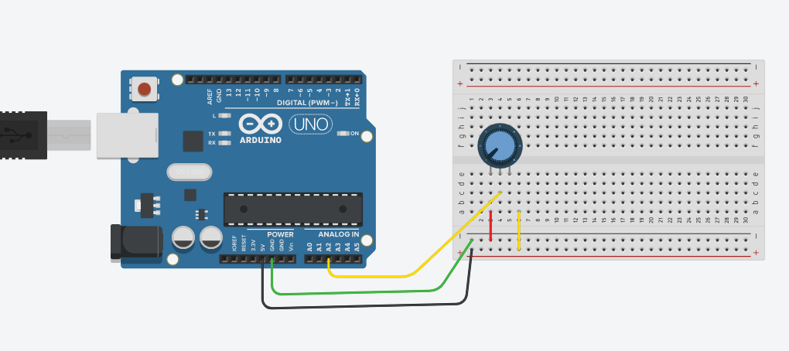

**Code:-**

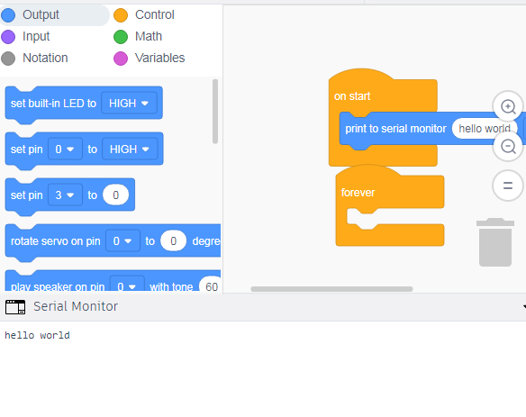

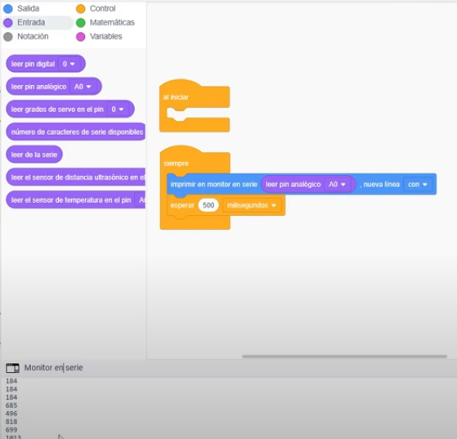

**Led blinking check using analog:-**

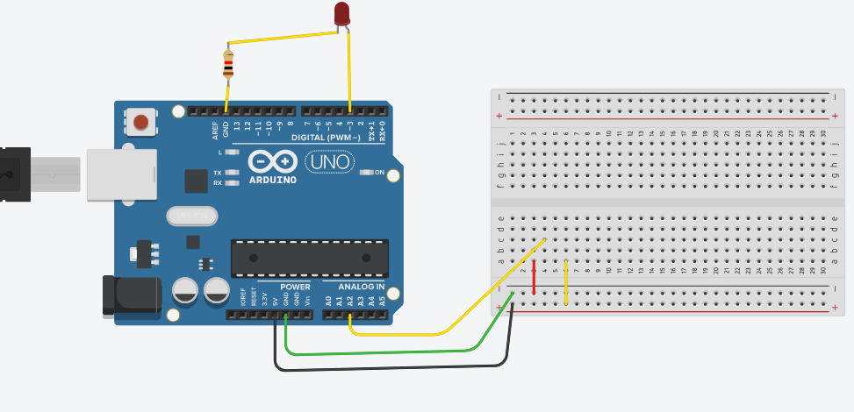

**Code:-**

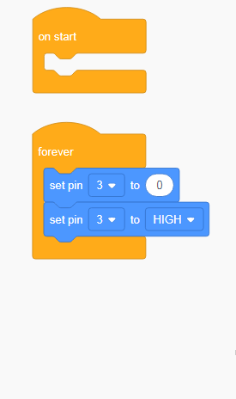

**Potentiometer using led light blinking system:-**

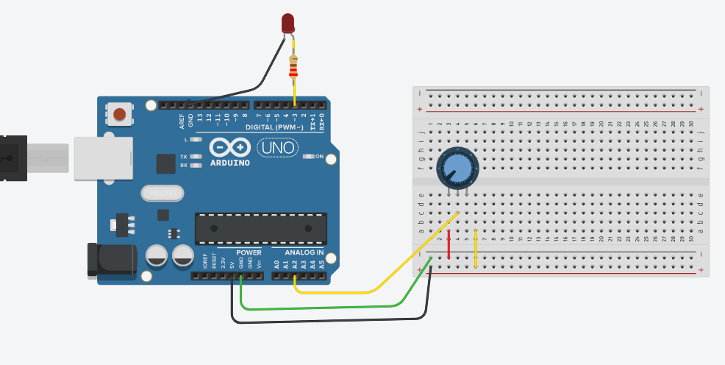

**Code:-**

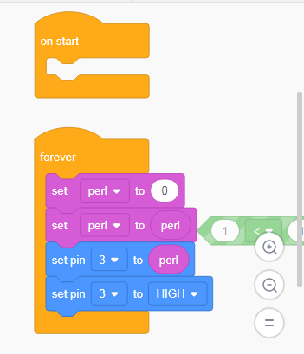

**DC motor using help of potentiometer to check the rotation:-**

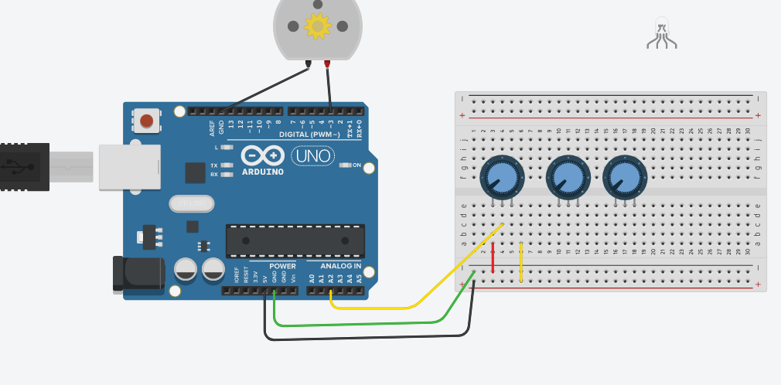

**Code:-**

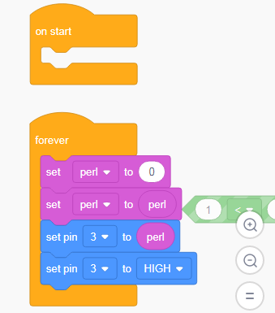

**LED rgb to blinking light checking using potentiometer:-**

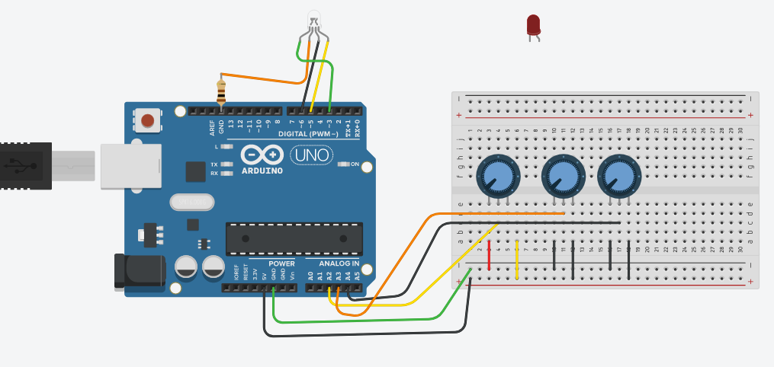

**Code:-**

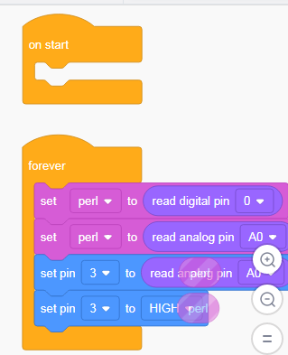

**Slide Switch using to check analog read:-**

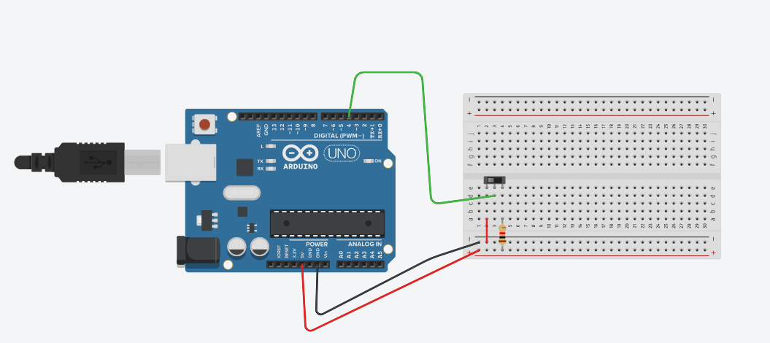

**Code:-**

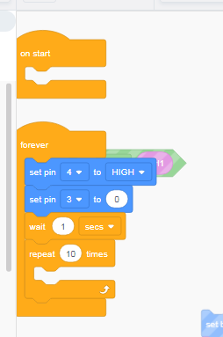

**Servo motor using to checking the rotation:-**

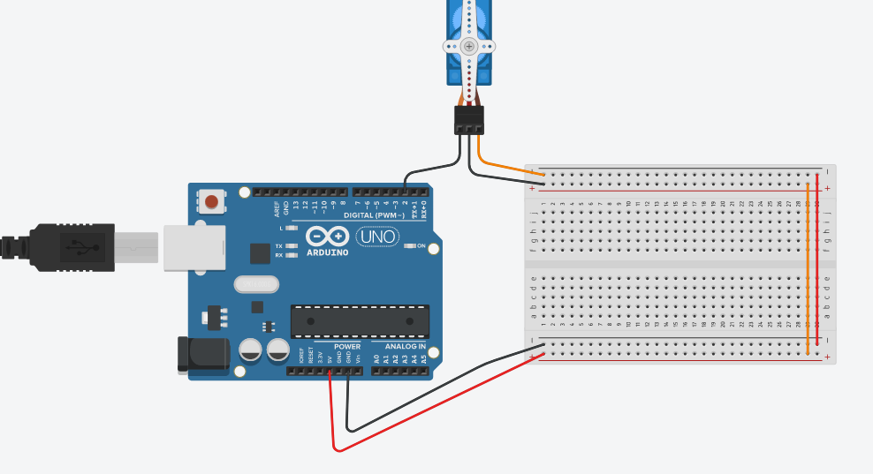

**Code:-**

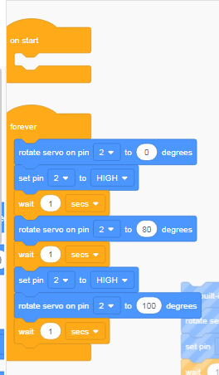

**Piezo using to sound system analysis:-**

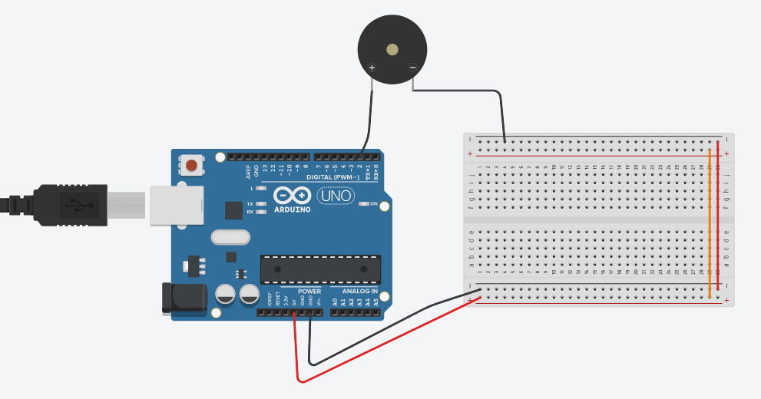

**Code:-**

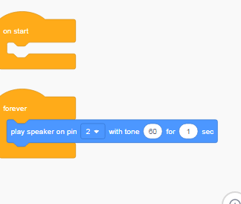

**Piezo using to switch press tone modulation checking:-**

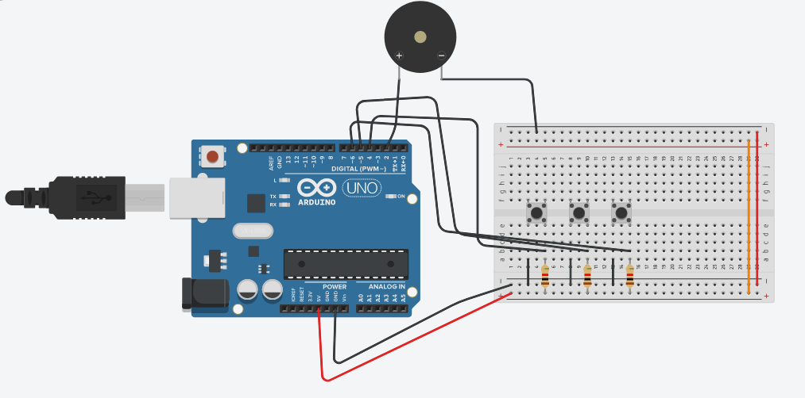

**Code:-**

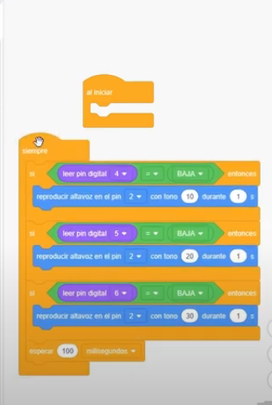

**Led rgb light using different color blinking:-**

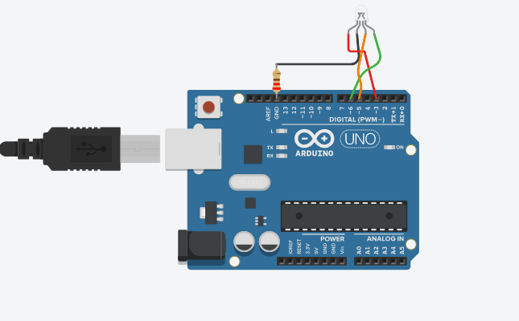

**Code:-**

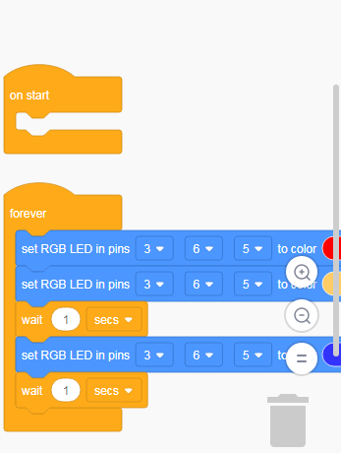

**Lcd monitor using generate hello world:-**

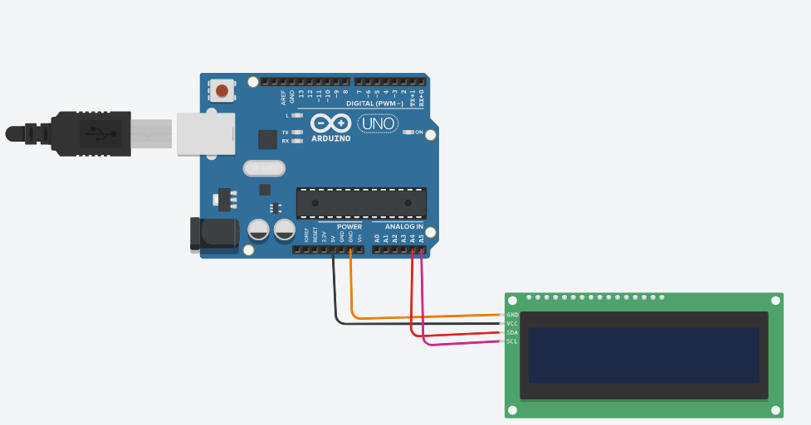

**Code:-**

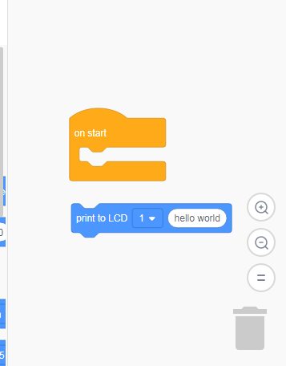

**Potentiometer reading print in the lcd display:-**

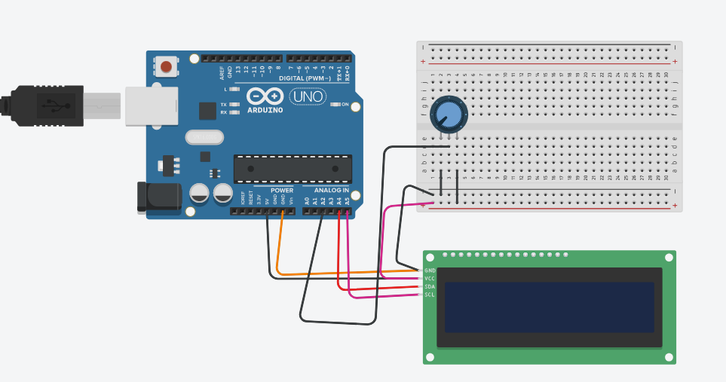

Coding:-

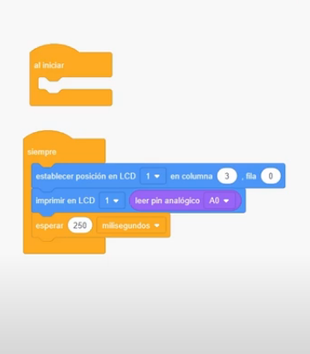

**Ldr using lcd monitor display:-**

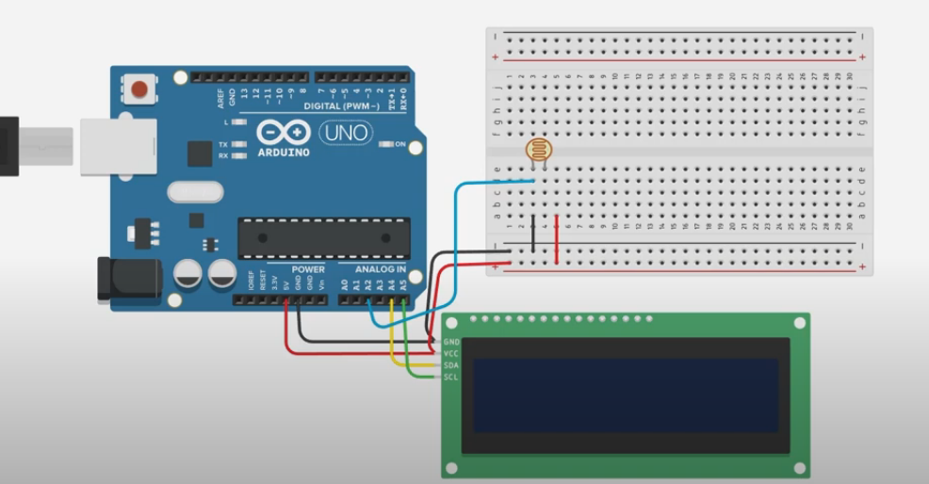

**Code:-**

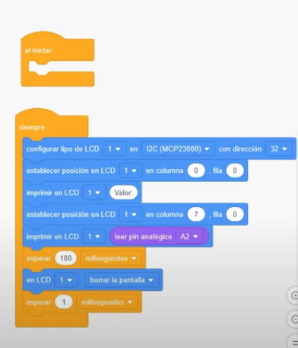

7 segment clock display output:-

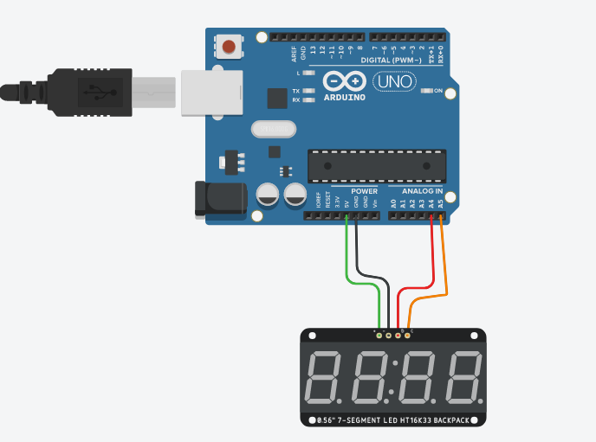

Code:-

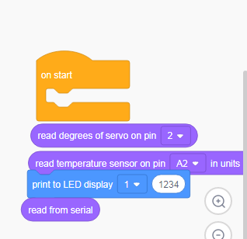

Servo motor rotating some clockwise direction slow time duration:-

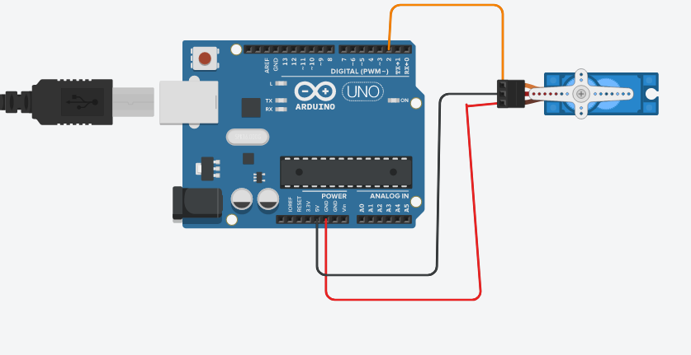

Code:-

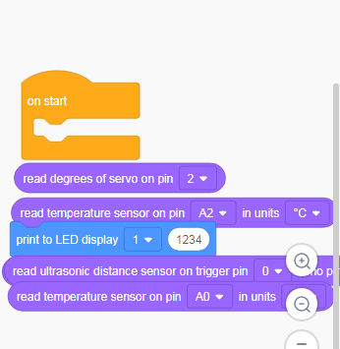

**Advantages:-**

* Excellent workspace.
* User-friendly interface for 3D modeling.
* Easy to import and modify existing models.
* High-quality exports in all major formats.
* Free and online and accessible
* Simple, easy to use 3D Design

**Images:-**

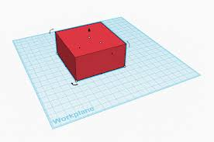

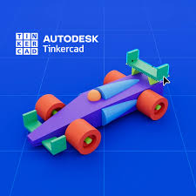

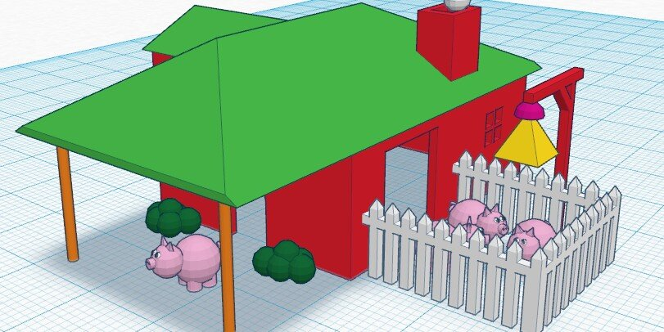

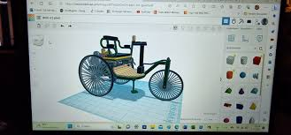

**Conclusion:-**

* The conclusion obtained is that students can use Tinkercad software well to understand programming competency upon a microcontroller.
* Most of the students showed a positive response when using Tinkercad and the obstacles experienced by a small part of students related to internal and external factors.
* Making 3D design, circuitry, and codeblocks simple yet feature-rich on both web and mobile devices helps promote creativity and also encourage students to learn even if they don't have physical resources for what they design.
* Tinkercad Lesson Plans are written in collaboration with educators to provide fun projects that align to academic standards like ISTE, Common Core, and Next Generation Science Standards (NGSS).